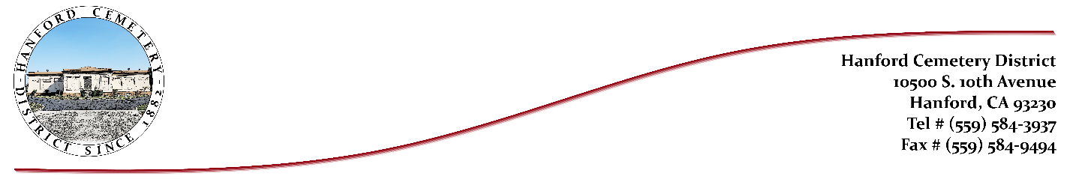
Board of Trustees
Loretta Toledo*Helen Wells*Ronnie Fagundes*Deborah Wilson*Theresa Barbeiro
HANFORD CEMETERY DISTRICT
Board Agenda January 8, 2025
The Hanford Cemetery District Board of Trustees will hold a Meeting on Wednesday,
January 8, 2026, at 8:15am, in the office of Hanford Cemetery District located at 10500 S.
10th Avenue, Hanford, CA 93230.

Start Meeting
- Call Meeting to Order
- Approve last minutes of Board Meeting, held on December 11, 2024
- Un-scheduled Public Appearance/Topics (3min. limit)
(For anything other than what is listed on the agenda.)

Old Business
- No old business

New Business
- Pre-need Contracts/Defaults
- Michelle Chappell
- Jennifer Sousa

- Grounds Equipment/Kasey
- Pauper/Catholic Church
- Financials/Burials

- Office Updates

- Adjourn Meeting

